BRAC University

MAT 216 : Linear Algebra and Fourier Analysis

Final Examination

6th September, 2022

Duration: 1 hour 30 minutes

Time: 11:30 am - 1:00 pm

Total Marks: 30

*Answer any 6 questions. Each question carries 5 marks.*

**Q1:** Find the solution space of the following homogeneous system of linear equations. Then find a basis and the dimension of the solution space.

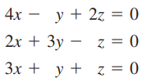

**Q2:** Find the coordinates of **x** = $(1, 2, -1)$ in $R^{3}$ relative to the (nonstandard) basis $B' = \{u_{1}, u_{2}, u_{3}\} = \{(1, 0, 1), (0, -1, 2), (2, 3, -5)\}$

**Q3:** Find the projection of the vector **x = $(2, 3, 4)$** onto the column space of the matrix A

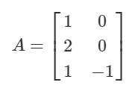

**Q4:** Determine whether the following set of vectors in $R^{3}$ is orthogonal, orthonormal, or neither. If they are not orthonormal, convert the basis to an orthonormal basis. You can use Gram-Schmidt Process or any other method that you know.



**Q5:** Find the eigenvalues and corresponding eigenvectors of the following matrix A

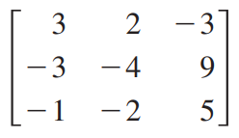

**Q6:** Find the least squares solution of the system $Ax = b$, where

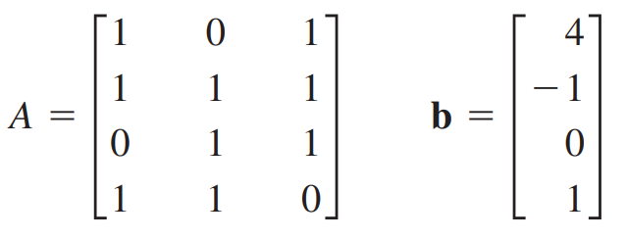

**Q7:** Find the rowspace and columnspace of the following matrix

